c.v. for
dr./ Asmaa Hassan Saad Hassan
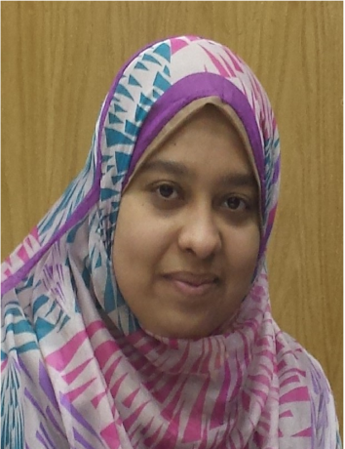
Firstly: personal Information

Name :Dr./ Asmaa Hassan Saad Hassan
Date of Birth:09/9/1991
Religion: Muslim
Marital Status: Married and has 2 kids
Current Position:
Lecturer of community organization in the faculty of social work, Assiut University
Highest scientific degree : ph.D ( Community organization )
Academic field: social work
Specialization: Community organization.
Foreign Languages (reading and writing): English , Arabic
Home Address: Sidi Bishr, Alexandria, Egept , street of cairo.
Work Address: faculity of social work , Assiut, Egept
Telephone : Mobile: 01110337039- 01279108394
E-mail: asmaahassan@aun.edu.eg

c.v.for Dr./Asmaa Hassan saad Hassan
Secondly: Positions in University

- Lecturer of community organization in the faculty of social work, Assiut University from 2022 till date.
- Assistant Lecturer of community organization in the faculty of s social work, Assiut University from May 2017 till 2022.
Thirdly : Scientific degreeS

- Ph.D. degree in social work (community organization) from faculty of social work in Assiut , Egept ,2022 under the title " The techniques of community organization method in the activating the anti - corrubtion committees in the governmental sector in Egept" .
- Masters degree in social work (community organization) from faculty of social work in Assiut , Egept ,2017 under the title " The coordination mechanisms between governmental and Non governmental organizations to develop the rural awareness with their rights in the social welfare services" .
- Bachelors degree in social work obtaining general grade (very good) in Assiut University , Egept in 2012.

c.v.for Dr./Asmaa Hassan saad hassan
Foreign Languages

Session in English (ELPET) -
Session in English (level one)-

fourthly. training session and experience certification

- Certificate of Appreciation from the field training in the Faculty of Arts.
- attended session for training of trainers in faculty and leadership development center – Assiut University , has passed the training programe of
. teaching with technology
. effective management of time and work stress
. crisis management
. conference organization
. publication of research in international journal
. student evaluation
. session in human development in the field of communication, interview preparation and personal cv.

